**The Zodiac Race Challenge**

From Feb 1 – Feb 11 2019 (Challenge ends at 1500 hours)

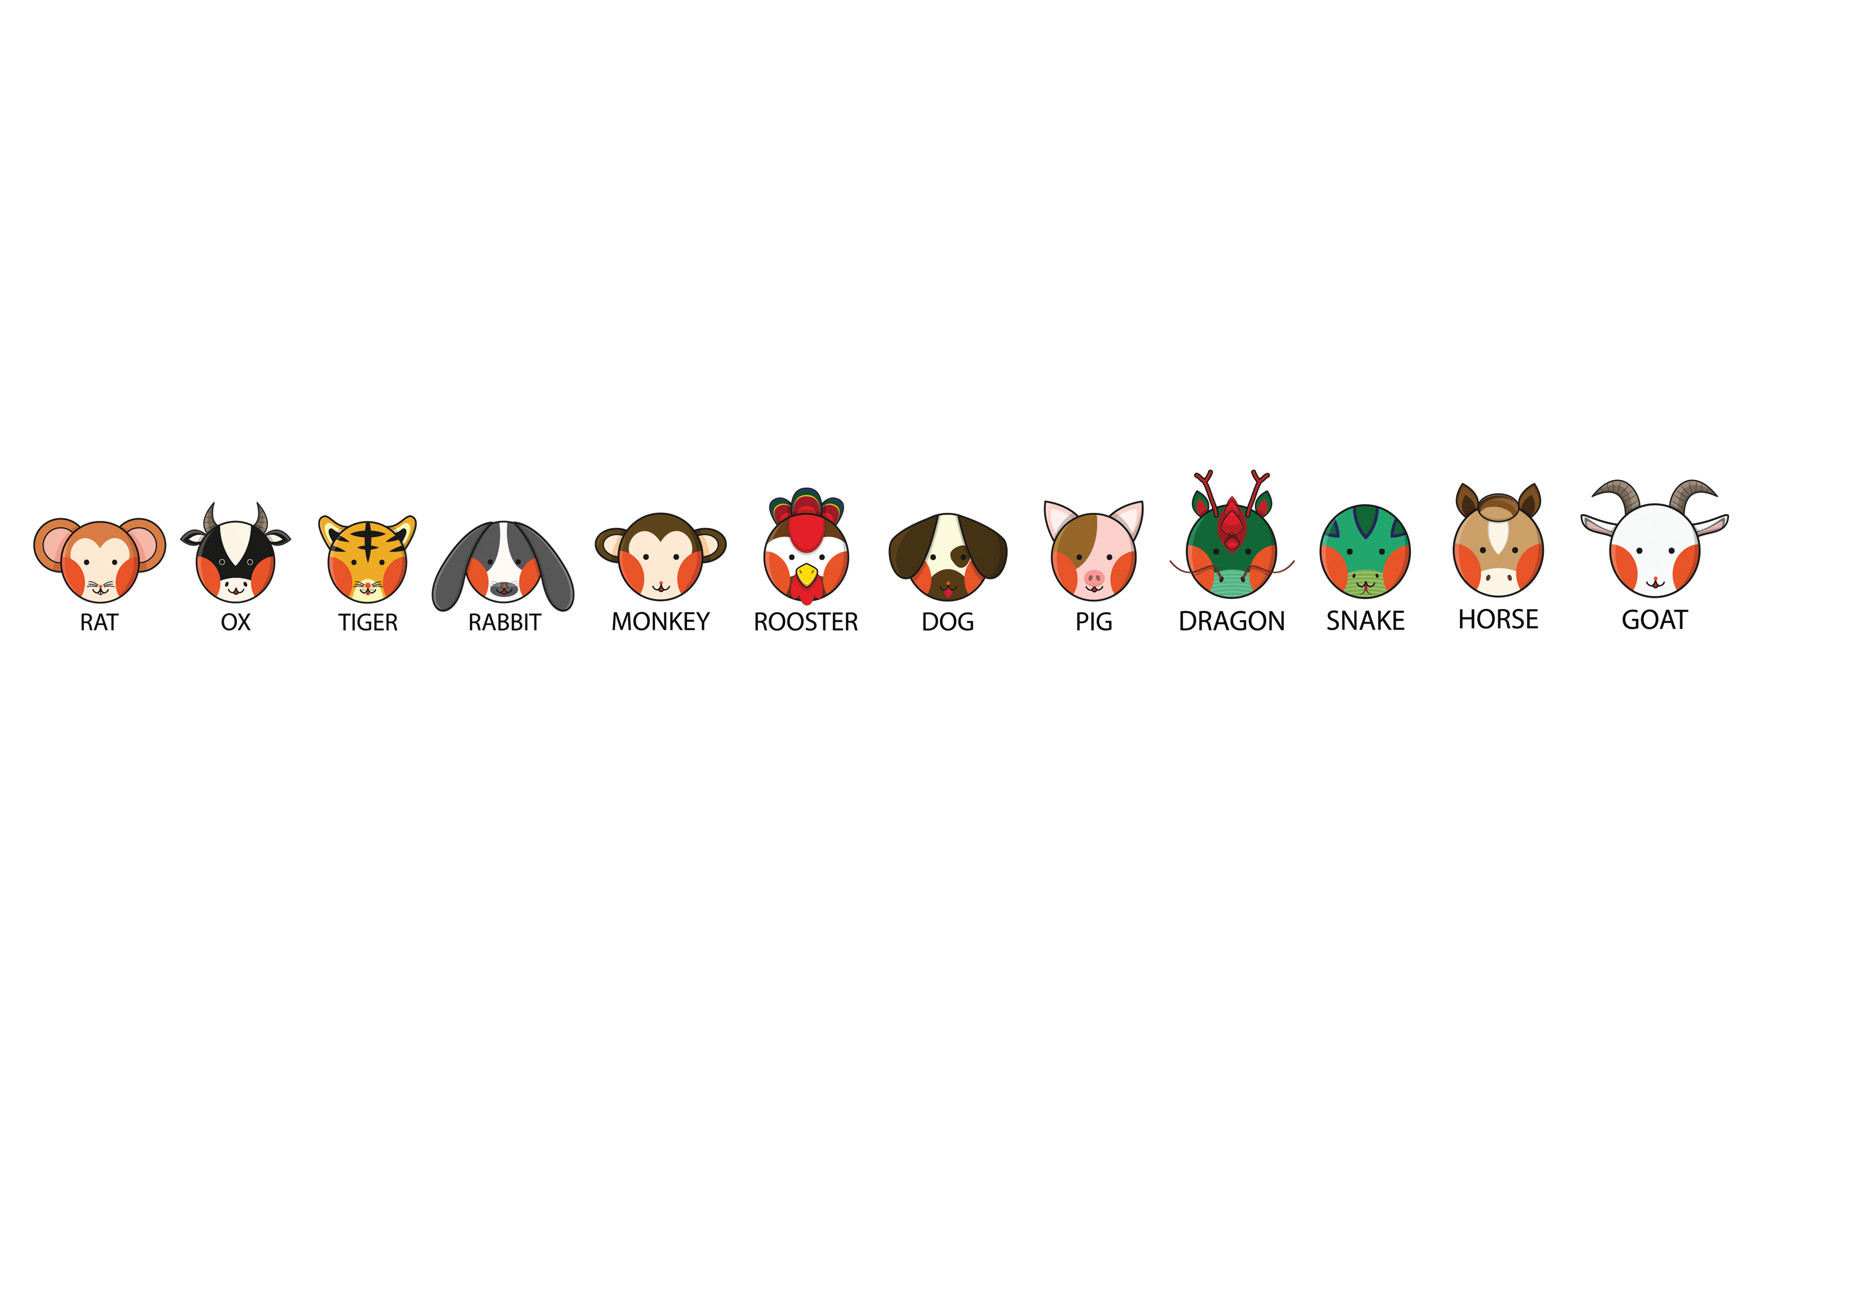

**Scenario:**

The Chinese New Year 2019 is coming.

As you know, many, many years ago, the animals on the Chinese Zodiac had a race to determine their position on the Chinese Zodiac. The winners then were (in order): rat, ox, tiger, rabbit, dragon, snake, horse, goat, monkey, rooster, dog, pig.

Some of the animals are complaining that they want a rematch.

The rematch Finals is taking place on this track that comprises of:

* Desert (km): 2345
* Mountain (km): 8764
* Water (km): 6689
* Land (km): 7332
* Forest (km): 1050
* Snow (km): 3741

The average temperature is estimated at 40 degrees Celsius, and it is raining throughout the race. The animals all had a good sleep on the night before the race.

**Challenge and Prizes:**

Your challenge is to **predict who came in First, Second and third by commenting on our workplace post on WOG [Data Science] E.g. 1st Rat, 2nd Dog, 3rd Dragon.**

*Note: we will not be able accepting entries via email so hop over to our workplace group!*

Challenge ends on 11th Feb 2019, 1500 hours.

|  |  |  |  |
| --- | --- | --- | --- |
| **Prizes** | **Prize description** | **Quantities** | **Dataset** |
| Grand prize  *(Lucky draw for the correct entries)* | Abalone gift set (Halal-certified) | 3 |  |
| Consolation  *(Lucky draw for all other entries)* | Exclusive Data Science Community tokens | 5 |  |

If you are unable to download the data set as attached in the email, it has been uploaded to our intranet portal [here](https://sgdcs.sgnet.gov.sg/sites/IDA-GoSync/DataScience/Resources/12.%20Zodiac%20Race_Feb%202019).

**Dataset:**

Luckily for you, the animals have been running a lot of trial races. The dataset given here captures the features of that particular trial, along with the top 3 winners and their respective timings. For example:



The way to interpret this is that Row 2 denotes a race which took place along a track that has:

- Desert (km): 7376

- Mountain (km): 4387

- Water (km): 7769

- Land (km): 7374

- Forest (km): 814

- Snow (km): 2677

The average temperature was 18 degrees Celsius, and it was raining throughout on that day. The animals also had a good sleep prior to the race.

For this particular trial:

- The winner was the rat with a timing of 218 minutes.

- The dog came in second with a timing of 242 minutes.

- The dragon came in third with a timing of 245 minutes.

**Hint:**

#1 - Logic does not apply ... so don't bother looking up how fast a goat travels across desert.

#2 - The official judge of the race, the Lion, apologised he recorded the values in a column wrongly, and asks that you disregard that column totally. He had forgotten which column that is, but remembers seeing a value of "ABCDE" in that column.

**Rules governing this Challenge**

* The Zodiac Race Challenge is available from 1 February to 11 February 2019 (both dates inclusive) and will end at 1500 hours.
* The Challenge is open to all Singapore public officers excluding staff from the organising team, GovTech’s Data Science and Artificial Intelligence Division.
* To participate in the Contest, participants must submit their prediction entry in the workplace post on **WOG [Data Science] group** within Contest Period.
* Each public officer can only submit one entry for the contest. Multiple entries are not accepted.
* Results will be announced within the month of February 2019.
* Most importantly, have fun!

